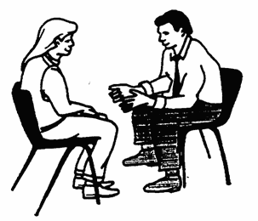
What helps to make therapy effective?
- This is Aarron Beck. Research has shown that one of the most important things that makes psychological therapy effective is the relationship with the client and the therapist. To make that relationship special for us, I will aim to show you/your child/teen empathy, genuineness, unconditional positive regard, respect and work will be built on your/your child’s strengths
- Therapy will be based around structured therapeutic activities and this helps both adults and children alike, so that they know a little what to expect and can take full responsibility for their part in their recovery.
- Work will be individualised but also using structured prepared handouts and activities, known to be useful to guide thinking and behaviour.
- The therapy will involve “Socratic” questioning, gentle guidance from a genuinely curious stance.
- Therapy will involve behavioural experiments to enable meaningful change outside of the therapy session. You will have homework experiments to complete to help to do this.
- For the client and therapist to have a little trust in the therapy “process” that going through the exercises and talking will help bring change just by being in the therapeutic relationship and working together.

